**Back test Report: DHR**

Name: Pranav Gada

Strategy Name: DHR

Instrument Type: BNF

Time Frame: Jan 2015 to Dec 2019, intraday 5 min data

Entry Logic: C1 - High of any of first 3 candle goes above prev day high,

C2 - Close of upto next 3 candles (after C1 is satisfied) goes below PDH

Sell at low of candle satisfying second condition (this price can come at any time throughout the day, and not necessarily on the immediate next candle).

Exit Logic: Trailing SL

Target: Trailing SL (exit at 3:25 if trailing SL not hit till EOD)

Stop-Loss: 0.1% above prev day high

Starting Equity: 100,000

Position Sizing: Entire capital

Instrument Type: Futures

Leverage: 4x

**Overall Performance**

|  |  |
| --- | --- |
|  | **Overall** |
| Starting Equity | 1,000,000 |
| Ending Equity | 2,860,436 |
| Time(Start-End) | Jan 2015 – Dec 2019 |
| Net Profit | 1860436 |
| Annualized Profit CAGR | 23.34% |
| Total Trades | 202 |
| Profitable Trades | 97 |
| Losing Trades | 105 |
| Avg Profit % | 0.54% |
| Avg Loss % | -0.17% |
| Pessimistic returns | 2.13 |
| Win Probability | 0.48 |
| Payoff Ratio | 3.17 |
| Trade Expectancy | 0.17% |
| Largest win (%) | 3.45% |
| Average Win(%) | 0.54% |
| Largest Loss((%) | -0.55% |
| Average Loss(%) | -0.17% |
| Median Loss (%) | -0.15% |
| Max Consecutive Wins | 6 |
| Max Consecutive Loss | 5 |
| Max Run Up (%) | 14.03% |
| Max Drawdown (%) | -5.93% |
| Sharpe Ratio | (23.34-4)/0.563  =1.22 |
| Std Error | 0.563 |
| Std Dev of wins | 0.615 |
| Std Dev of Loss | 0.113 |
| RiskReward Ratio(Net Profit(%)/Max Drawdown(%)) | 31.36 |
| Model Efficiency(Net Profit/Perfect Profit)*100 | 60.36 |

**Equity Curve**

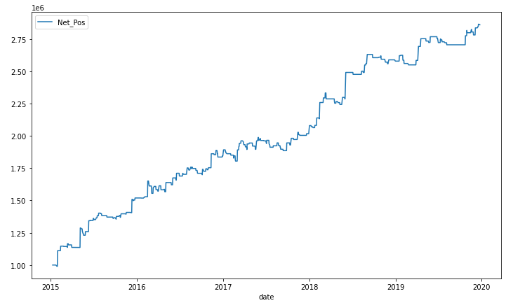

**Distribution of Trades:**

